Game Interface

The main interface

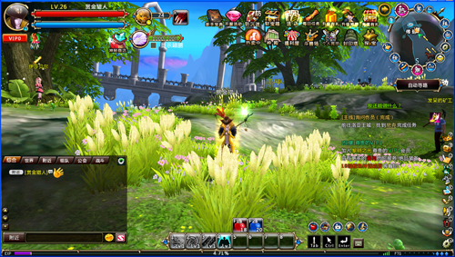

1, the role of information window

2, the guardian of the window

3, wings window

4, mystery shop

5, the chat box

6, skill bar

7, APP window

8, maps and other information and functions window

9, the task information bar

10, the function shortcut bar

11, the delay information

12, the value of information fatigue

Detailed interface

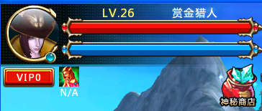

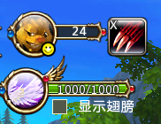

1, the role of Avatar

2, character level

3, character names

4, the role of health display - When life is 0 character dies

5, the role of mana display - using the skills consume mana role

6, VIP grade

7, the role of buff

8, mystery shop, you can buy discounted merchandise display activity.

9, guardian avatar

10, the guardian level

11, guard skills

12, the guardian of domesticated settings automatically

13 wings logo

14 wings physical value

15, whether to display the wings

Small Map & various functions window

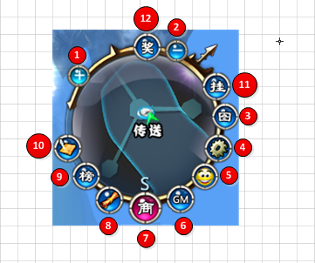

1 small map to enlarge

2, narrow small map

3, the map

4, system settings

5, emotes

6, contact GM

7, Mall

8, the daily guide

9, rankings

10, Today's Events

11, Constellation prayer

12, to receive gifts

Chat box

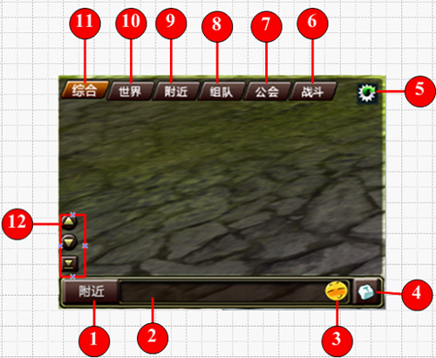

A chat window switch

2, the input box

3, expression selection box

4, the input method switch

5, chat system settings

6, Combat Information

7, Association of Information

8, team information

9, near the information

10, World Information

11, integrated information

1) Pull the chat message

2) information on the drop-down chat

3) pulled to the bottom of the chat messages

12, the operation shortcut bar

Skill bar

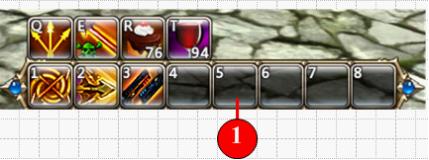

Drag the skills or drugs, you can use the skills bar

Function shortcut bar

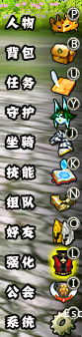

1, character attributes (shortcut P) - contains basic information character

2, backpacks bar (shortcut key B) - open the backpack interface

3, the task bar (shortcut U) - open the Task interface

4, guard button (shortcut key Y) - Open guardian interface

5, the horse button (shortcut bar J) - Open horse interface

6, skill button (fast interface K) - Open Skill Interface

7, the team button (shortcut key N) - Open Interface team

8, the Friends menu (shortcut O) - Friends menu opens

9, strengthening button (shortcut L) - Open strengthen interface

10, Guild button (shortcut I) - Open guild menu

11, the system menu (shortcut key ESC) - Open the System menu

Delay information and Fatigue

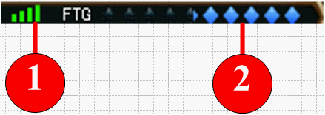

1, the delay of information - Displays the current network status

2, the fatigue value - Displays the current value of information fatigue

Task Display information

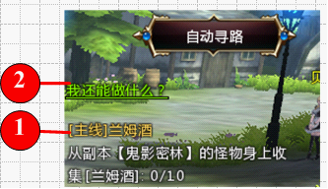

1, shows the current task information, click to automatically find its way

2, click [I can do] to display the current task can be accessed